MySQL Assignment-1

CREATION:-

create database employee;

use employee;

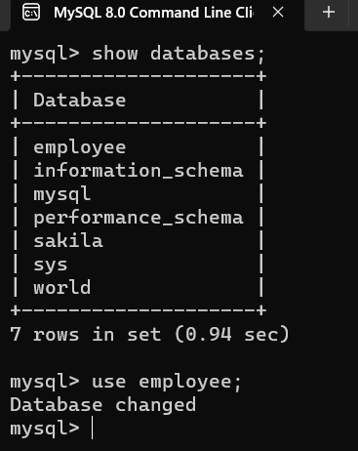

QUESTION 1:

Assignment-1 --- Create two tables: EmployeeDetails and EmployeeSalary. AND

Columns for EmployeeDetails: EmpId FullName ManagerId DateOfJoining City && Columns for EmployeeSalary: : EmpId Project Salary Variable.

ANSWER:

Create EmployeeDetails table:-

create table employee_details(

-> empId int,

-> empFullName varchar(20),

-> managerId int,

-> dataOfJoin date,

-> empCity varchar(20));

Create EmployeeSalary table:-

create table employee_salary(

-> empId int,

-> project varchar(20),

-> salary int);

show tables;

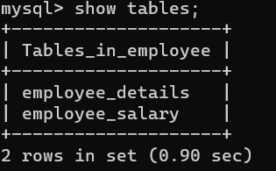

INSERTION:-

/* ADD RECORDS IN BOTH TABLES */

1. employee_details TABLE values:

insert into employee_details(empId,empFullName,managerId,dataOfJoin,empCity) values(101,"Manik",1001,"1995-02-01","Mumbai"),(102,"Jackie",NULL,"2021-07-05","Pune"),(103,"Sakthi",1002,"2020-02-08","Kolkata"),(104,"Mythili",1003,"2020-06-03","Chennai"),(105,"Maria",NULL,"2023-04-08","Bangalore"),(106,"Sankar",1004,"1990-01-09","Delhi"),(107,"Raja",NULL,"2022-11-20","Hyderabad"),(102,"Jackie",1005,"2021-07-05","Pune"),(108,"Jaya",NULL,"2022-08-04","Trivandrum"),(109,"Mehta",NULL,"2023-05-03","Chennai"),(110,"Varun",NULL,"2023-07-30","Pune");

1. employee_salary TABLE values:

insert into employee_salary(empId,Project,Salary)values(101,"P1",75000.00),(102,"P2",30000.00),(103,"P1",45000.00),(104,"P2",42000.00),(105,"P1",20000.00),(106,"P2",67000.00),(107,"P2",40000.00),(108,"P1",28000.00);

select * from employee_details;

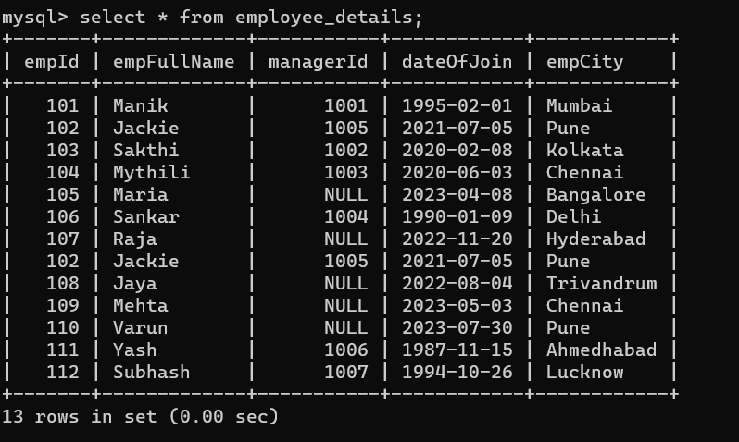

select * from employee_salary;

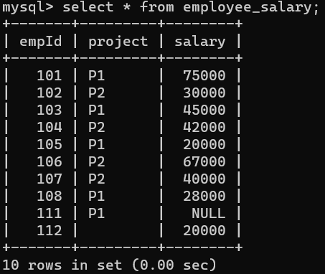

QUESTION 2: SQL Query to fetch records that are present in one table but not in another table.

ANSWER:-

Using NOT IN:

select * from employee_details where empId not in(select empId from employee_salary);

Using NOT EXISTS:

select * from employee_details where not exists(select empId from employee_salary where employee_details.empId = employee_salary.empId);

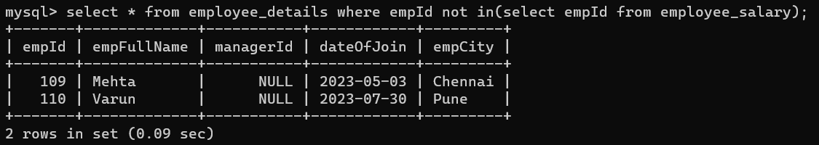

QUESTION 3: SQL query to fetch all the employees who are not working on any project.

ANSWER:-

select empId, empFullName from employee_details where not exists(select Project from employee_salary where employee_details.empId = employee_salary.empId);

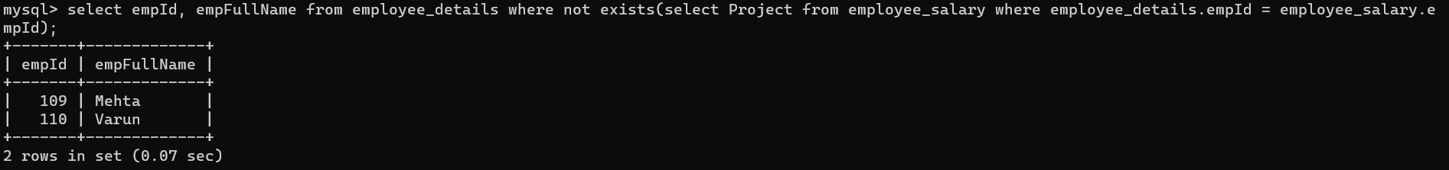

QUESTION 4: SQL query to fetch all the Employees from EmployeeDetails who joined in the Year 2020.

ANSWER:-

select * from employee_details where year(dateOfJoin)=2020;

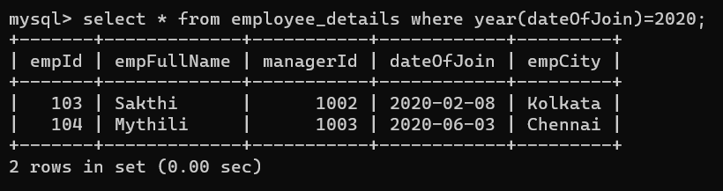

select * from employee_details where dateOfJoin between date '2020-01-01' and date '2020-12-31';

QUESTION 5: Fetch all employees from EmployeeDetails who have a salary record in EmployeeSalary.

ANSWER:-

Using INNER JOIN:-

select ed.empId, ed.empFullName, es.salary from employee_details ed join employee_salary es on ed.empId=es.empId;

Using SUB-QUERY:-

select * from employee_details ed where exists(select * from employee_salary es where ed.empId=es.empId);

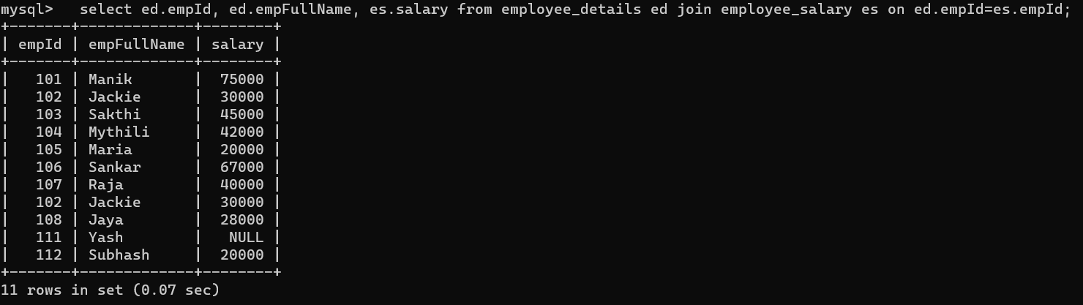

QUESTION 6: Write an SQL query to fetch a project-wise count of employees.

ANSWER:-

select Project, count(empId) as ProjectWise_Emp_Count from employee_salary group by Project;

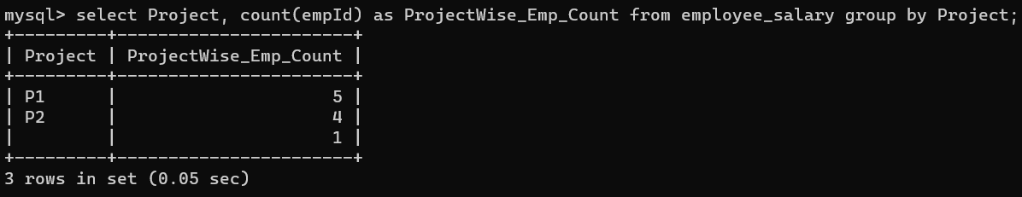

QUESTION 7: Fetch employee names and salaries even if the salary value is not present for the employee.

ANSWER:-

select ed.empFullName, es.Salary from employee_details ed left join employee_salary es on ed.empId=es.empId;

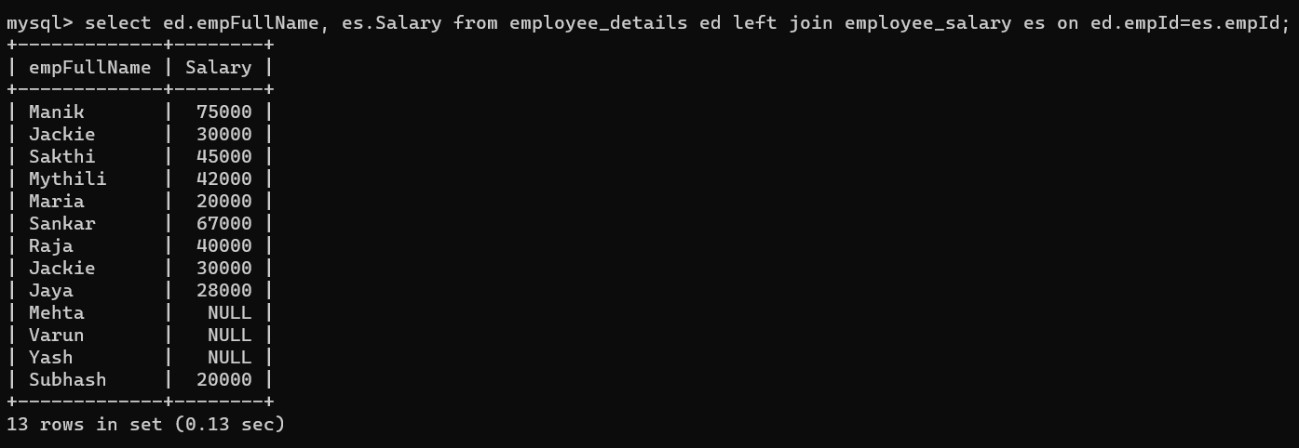

QUESTION 8: Write an SQL query to fetch all the Employees who are also managers.

ANSWER:-

select * from employee_details where managerID;

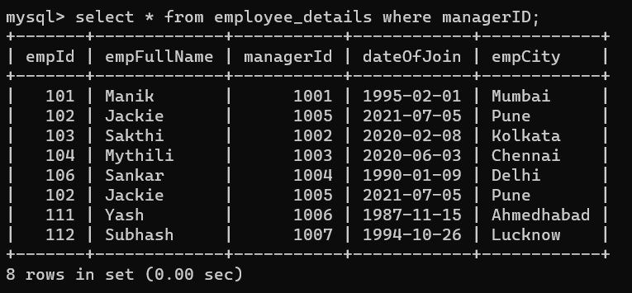

QUESTION 9: Write an SQL query to fetch duplicate records from EmployeeDetails.

ANSWER:-

select empId, count(*) as DuplicateCount from employee_details group by empId having count(*)>1;

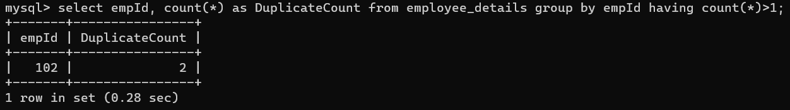

QUESTION 10: Write an SQL query to fetch only odd rows from the table.

ANSWER:-

Query for employee_details table:-

select * from(select *, row_number() over(order by empId) as OddRowNum from employee_details) ed where ed.OddRowNum%2=1;

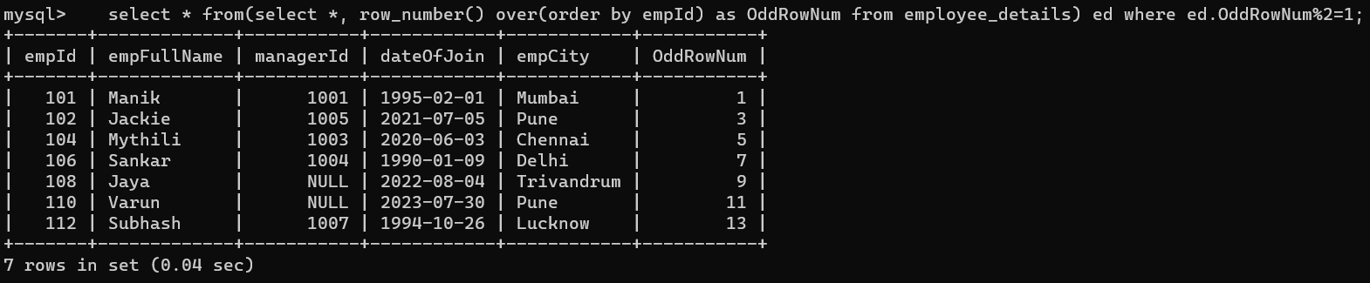

Query for employee_salary table:-

select * from(select *, row_number() over(order by empId) as OddRowNumbers from employee_salary) es where es.OddRowNumbers%2=1;

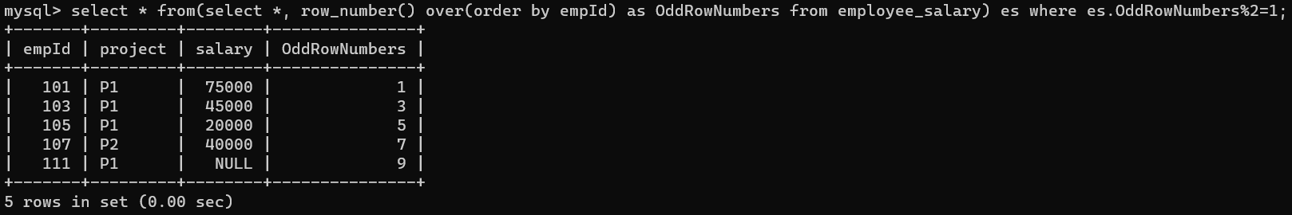

QUESTION 11: Write a query to find the 3rd highest salary from a table without top or limit keyword.

ANSWER:-

select ed.empId,ed.empFullName,es.Salary from employee_details ed join employee_salary es on ed.empId=es.empId where Salary=(select max(Salary) from employee_salary where Salary < (select max(Salary) from employee_salary where Salary < (select max(Salary) from employee_salary)));

